RESOLUTION NO.__________

RE: CERTIFICATE OF APPROPRIATENESS UNDER THE
PROVISIONS OF THE ACT OF THE PENNSYLVANIA
LEGISLATURE 1961, JUNE 13, P.L. 282 (53
SECTION 8004) AND BETHLEHEM ORDINANCE NO.
3952 AS AMENDED.

WHEREAS, it is proposed to install several window and door signs and place a moveable/sandwich board sign in the public right-of-way at 230 E. Third St.

NOW, THEREFORE, BE IT RESOLVED by the Council of the City of Bethlehem that a Certificate of Appropriateness is hereby granted for the work.

Sponsored by: (s)

(s)

ADOPTED BY COUNCIL THIS DAY OF

(s)
President of Council

ATTEST:

(s)
City Clerk

HISTORIC CONSERVATION COMMISSION

CASE # 621– It is proposed to install several window and door signs and place a moveable/sandwich board sign in the public right-of-way at 230 E. Third St.
OWNER/APPLICANT: Bethlehem Realty LLC/ Alberto Cruz

The Commission upon motion by Ms. Starbuck seconded by Mr. Evans adopted the proposal that City Council issue a Certificate of Appropriateness for the proposed work described herein:

- The proposal to install several window and door signs and place a moveable/sandwich board sign in the public right-of-way at 230 E. Third St. was represented by Alberto Cruz and Maey Jimenez.
- All signs have a bright pink background with white lettering.
- Option 1 – New signs will be installed as per the sketch by the Historic Officer. A drawing from the sign maker should be submitted to the City for review.
- Option 2 - Window signs are already installed at the top and bottom of the glass and are 5’ wide x 2’ high respectively. The sign at the bottom of the display windows will be removed. The remaining sign will read “We Fix it All” with I-phone pictures.
- A sign above the door and at the top of the door are 3’ wide x 2’ high and 2 1/2’ wide x 2’ high respectively. The sign on the door will be removed. The remaining transom sign will read Happy Fix” with telephone # and smilely faces
- The sandwich board sign must be approved by City of Bethlehem Public Works department. The colors are acceptable for the business and the historic district.
- The motion to approve the proposal was unanimously approved.

CU: cu
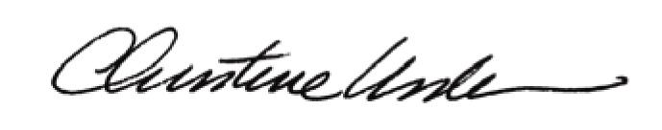

By:

Date of Meeting: August 21, 2017 Title: Historic Officer

